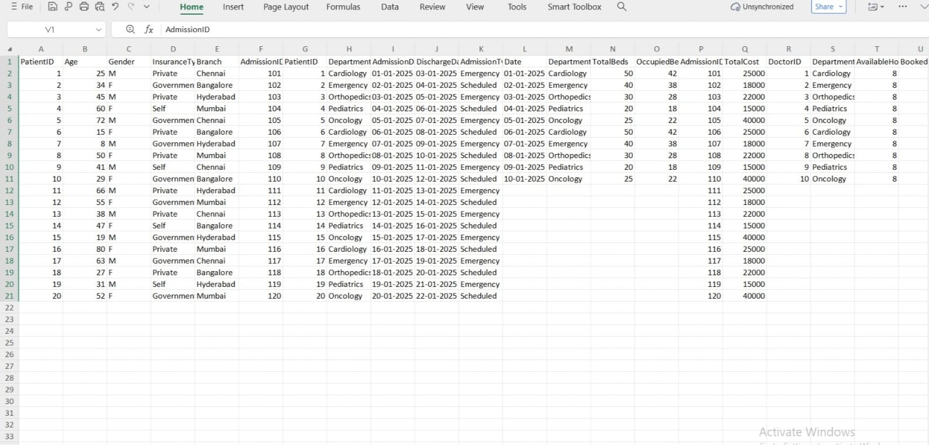

1️⃣ Categorical Data (Qualitative)
Examples in your dashboard
Department (Cardiology, Emergency, Pediatrics, Oncology)
Admission Type (Emergency / Scheduled)
Patient Outcome (Recovered, Improved, Transferred)
📌 What it shows
Comparison between different groups or categories
Distribution of patients across departments and admission types
📊 Where it is shown
Stacked Column Chart (Admissions by Type)
Pie Chart (Bed occupancy by department)
Card (Patient outcome)
✔ When to use
To compare departments or categories
To understand patient flow and outcomes
❌ When to avoid
When categories are too many (hard to read)
When exact numerical trend is required
🔍 Insights generated
Emergency admissions are higher than scheduled
Certain departments handle more patients
Majority patient outcomes are “Improved”
2️⃣ Numerical Data (Quantitative)
Examples in your dashboard
Total Beds
Occupied Beds
Total Cost
Available Hours / Booked Hours
📌 What it shows
Magnitude, volume, and totals
Measurement of hospital capacity and workload
📊 Where it is shown
Card (Total Beds)
Clustered Column Chart (Doctor availability vs booking)
Line & Column Chart (Cost per admission)
✔ When to use
For KPIs and performance metrics
To measure workload and resource usage
❌ When to avoid
Showing raw numbers without aggregation
When comparison context is missing
🔍 Insights generated
Doctors are highly utilized in some departments
Certain admissions have very high treatment cost
Bed capacity is close to full utilization
3️⃣ Time-Series Data (Date & Time)
Examples in your dashboard
Admission Date
Discharge Date
📌 What it shows
Trends over time
Changes in hospital activity
📊 Where it is shown
Line Chart (Admissions trend)
Line & Stacked Column Chart
✔ When to use
To identify peak days or periods
For trend and pattern analysis
❌ When to avoid
When there is only one date value
If dates are missing or inconsistent
🔍 Insights generated
Admission volume changes over time
Helps identify peak operational periods
4️⃣ Percentage / Ratio Data
Examples in your dashboard
Bed Occupancy %
Doctor Utilization %
📌 What it shows
Efficiency and utilization level
Performance against capacity
📊 Where it is shown
Gauge Chart
KPI Cards
✔ When to use
To monitor operational efficiency
To identify over-utilization or under-utilization
❌ When to avoid
When absolute numbers are more important
For very small datasets
🔍 Insights generated
High bed occupancy indicates resource pressure
Doctor workload nearing maximum capacity
5️⃣ Hierarchical Data
Examples in your dashboard
Branch → Department
Department → Doctor
📌 What it shows
Multi-level analysis
Drill-down capability
📊 Where it is shown
Waterfall Chart (Branch-wise patient load)
Department-based visuals

